ANIMAL PROFILE (FOR ADOPTION)
Blue

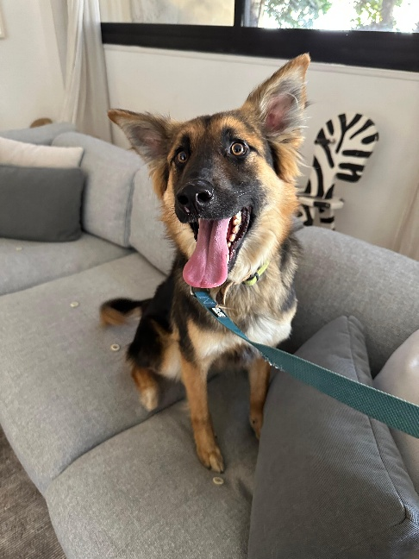

INFO | DETAIL
Dog or cat | Dog
Name | Blue
Gender | Male
Sterilized | Yes
Type of hair | Long
Size of the dog | Large  Length from nose till beginning of tail: 85cm  Height from the head down to the ground: 65cm  Weight: 20kg
Can the animal be with children | Not tested
Can he live with cats? | Not tested
Can he live with dogs? | Yes
Can the dog be alone at home for a while? | Yes
Can the dog walk the stairs up and down | Yes
Can the dog walk on leash | Yes
Is the dog potty trained | Yes
Does the dog need a garden attached to the house | Yes, preferably
How active is the dog | Active
Is the dog affectionate | Yes, once he warms up
Does the dog listen very well to the owner | Not tested
Does the dog have a hunting instinct | Not tested
Is the dog social (nice) with people he/she does not know | Yes
Does the dog love to play | Yes, sometimes
Is the dog alert (defending the owner) | No tested
Does the dog have a passport? | Yes
Is the dog recently vaccinated? | Yes
Is the dog microchipped | Yes
Does the animal have physical issues? | No
Does the animal use special medicines? | No
Does the dog need special petfood? | No
Does the dog have attitude problems? | He is a lovely dog; he will come to you to ask for pets and love. He is so sweet and affectionate.
Can the dog be in a car? | Yes
What is the breed of the dog | Mixed Shepherd
Date of birth | 25-July-2024
Age | 1 year & 8 months
Describe story | He was dumped as a puppy with his mom and siblings in a parking lot and some people wanted to poison them
Temperament | He is a lovely boy. He will come to you asking for pet and love.
Health status | No health issues
Instagram | No Instagram link
Date | 4-Apr-26

