ANIMAL PROFILE (FOR ADOPTION)
Goldie

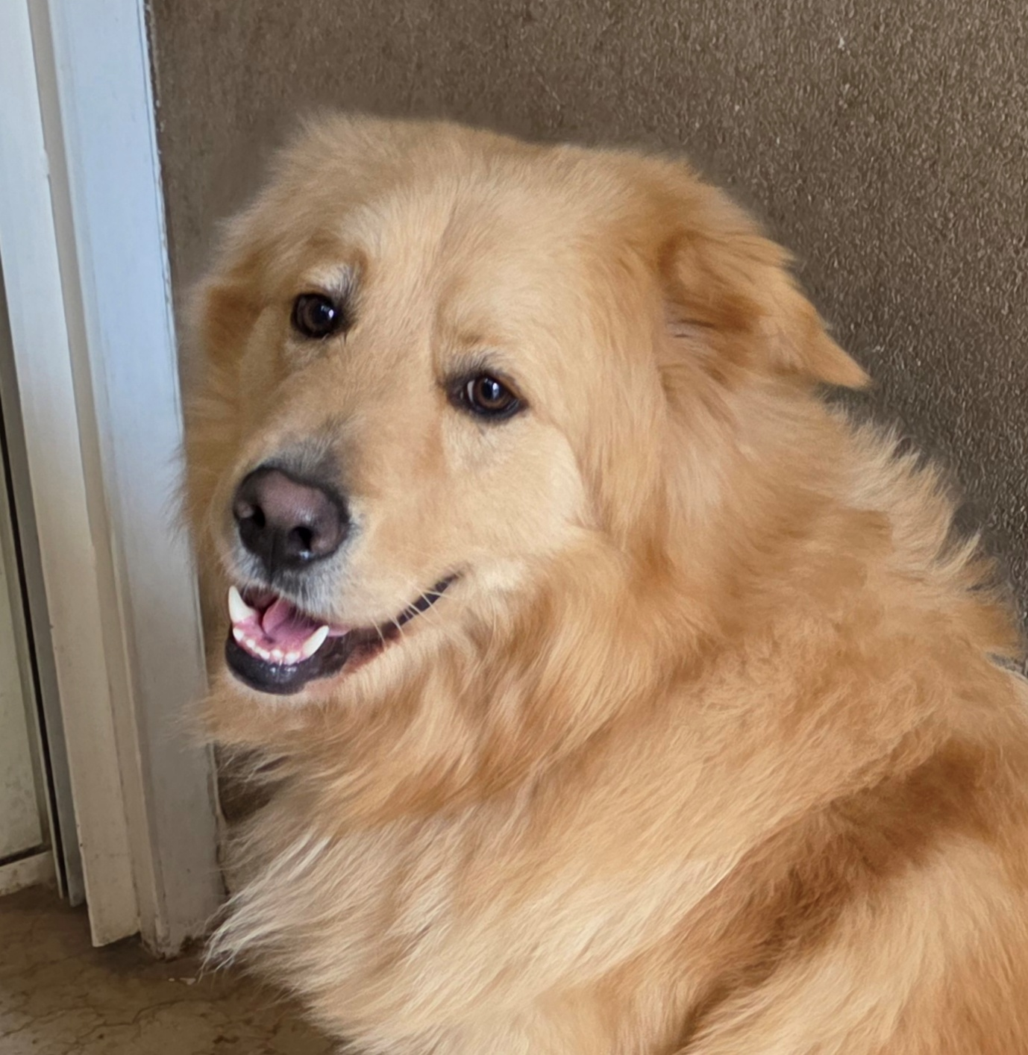

INFO | DETAIL
Dog or cat | Dog
Name | Goldie
Gender | Male
Sterilized | yes
Type of hair | Medium
Size of the dog | Medium to large (length head to tail: 97 cm. Height head to ground: 58 cm)27 kg
Can the animal be with children | Yes, but he is hyperactive, and can jump on people playfully
Can he live with cats? | No, because he is hyperactive
Can he live with dogs? | Yes, but better not with another dominant male
Can the dog be alone at home for a while? | yes
Can the dog walk the stairs up and down | yes
Can the dog walk on leash | Yes, but he does leash pulling
Is the dog potty trained | Started. Has to go out 4 times a day
Does the dog need a garden attached to the house | Better if there is a garden
How active is the dog | He is active
Is the dog affectionate | Very affectionate
Does the dog listen very well to the owner | Yes, but he needs boundaries/discipline
Does the dog have a hunting instinct | moderate
Is the dog social (nice) with people he/she does not know | yes
Does the dog love to play | yes
Is the dog alert (defending the owner) | No
Does the dog have a passport? | yes
Is the dog recently vaccinated? | yes
Is the dog microchipped | yes
Does the animal have physical issues? | Both front legs were broken when he was rescued. But he had successful surgery
Does the animal use special medicines? | no
Does the dog need special petfood? | no
Does the dog have attitude problems? | no
Can the dog be in a car? | yes
What is the breed of the dog | Golden Retriever mix
Date of birth | N/A (rescued dog)
Age | Estimated between 18 to 24 months
Describe story | I found him dying of hunger and his injuries on the side of the road in Aley, close to my home. I was able to retrieve him thanks to help from Animal Lebanon. Both his front legs were broken, and one was so badly broken that the doctor was considering amputation. I insisted on trying to save his shattered leg before considering amputation. The surgery on each leg was successful (metal rods were used to keep the bones in place), and Goldie was able to recover beautifully at my place.
Temperament | Affectionate, playful
Health status | Good
Instagram
Date | 6 May 2026

